Business Problem**:**

Forecast the Coca-Cola prices data set. Prepare a document for each model explaining how many dummy variables you have created and RMSE value for each model. Finally, which model you will use for Forecasting.

Data:

Data has Quarter and Sales and converted into Time Series.

Pre-processing Data:

There was no outlier and NA in the data. Divide them with frequency 4 because a year has 4 quarters. Partition the dataset 1:38 and last four (39:42 – means year) we have to predict it. So, last four is test dataset.

Building the Model:

Build the model for Time Series.

Visualization:

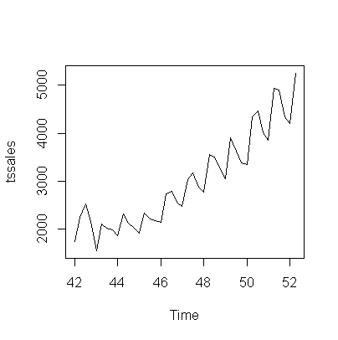

Using HoltWinter function**:**

Training the model using alpha = 0.2, beta =F and Gama =F and predict it and Map it.

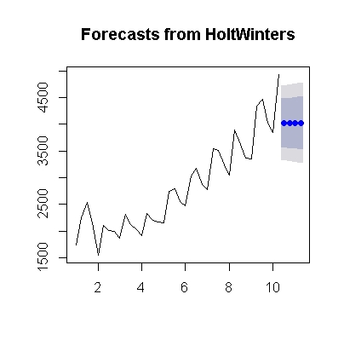

Mapping value: 16.634

Training the model using alpha = 0.2, beta =0.15 and Gama =F and predict it and Map it.

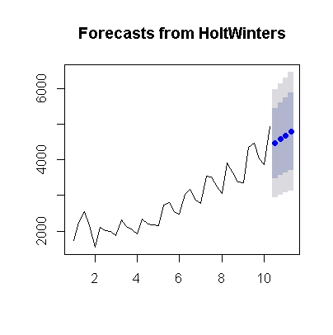

Mapping value: 8.7477

Training the model using alpha = 0.2, beta =0.15 and Gama =0.05 and predict it and Map it.

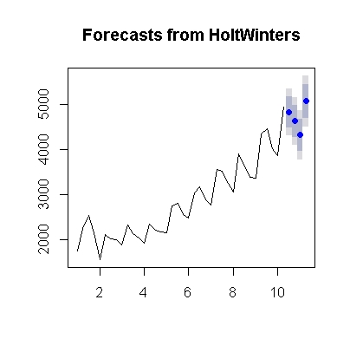

Mapping value: 3.5841

Training the model using beta =F and Gama =F and predict it and Map it.

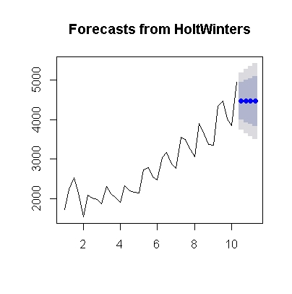

Mapping value: 9.0930

Training the model using Gama =F and predict it and Map it.

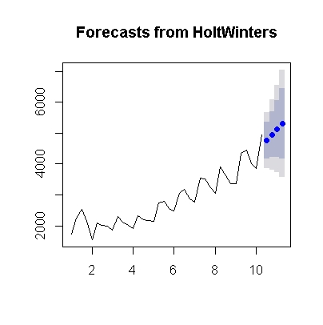

Mapping value: 8.627

By running with only train dataset:

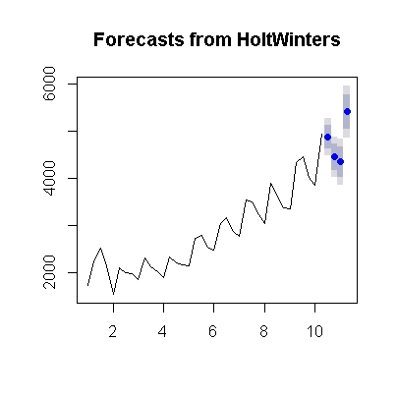

Mapping value: 2.3972

**RMSE Values for different models:**

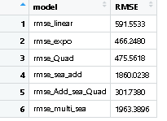

**Summary of the model:**

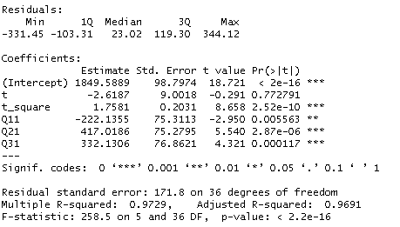

Business Problem:

Forecast the Airlines Passengers data set. Prepare a document for each model explaining how many dummy variables you have created and RMSE value for each model. Finally, which model you will use for Forecasting.

Data:

Data has Month and Passenger and converted into Time Series.

Pre-processing Data:

There was no outlier and NA in the data. Divide them with frequency 12 because a year has 12 months. Partition the dataset 1:84 and last four (85:96 – means year) we have to predict it. So last 12 are the test dataset.

Building the Model:

Build the model for Time Series.

Visualization:

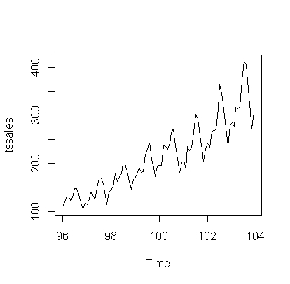

Using HoltWinter function:

Training the model using alpha = 0.2, beta =F and Gama =F and predict it and Map it.

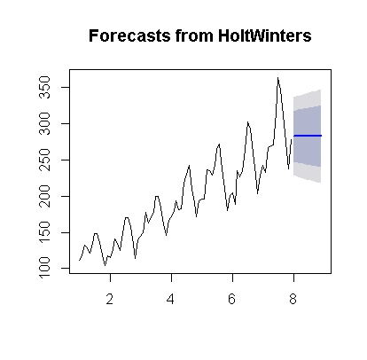

Mapping value: 17.23

Training the model using alpha = 0.2, beta =0.15 and Gama =F and predict it and Map it.

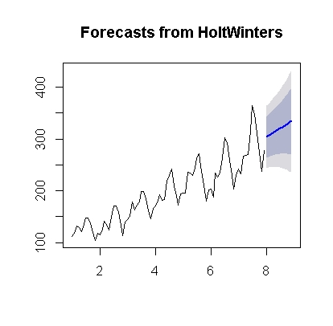

Mapping value: 11.216

Training the model using alpha = 0.2, beta =0.15 and Gama =0.05 and predict it and Map it.

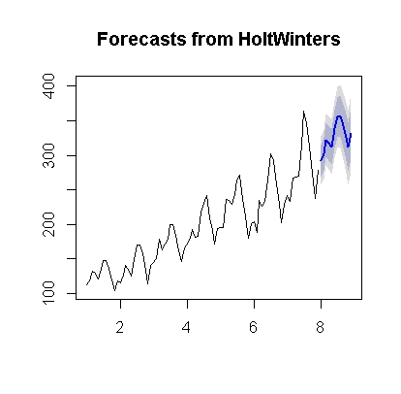

Mapping value: 7.256

Training the model using beta =F and Gama =F and predict it and Map it.

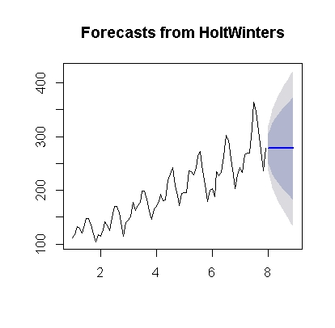

Mapping value: 18.555

Training the model using Gama =F and predict it and Map it.

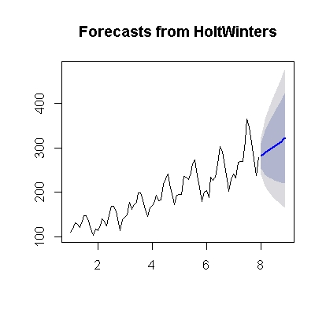

Mapping value: 13.104

By running with only train dataset:

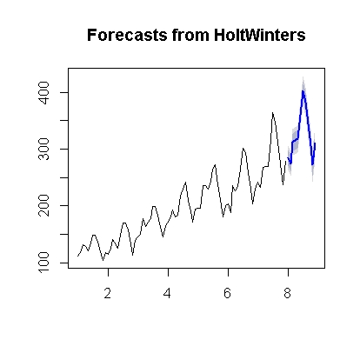

Mapping value: 1.7308

RMSE Values for different models mention in table:

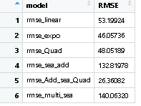

Summery details of model:

